**Name: Harshavardhana K**

**USN: 1BM18CS035**

**Program Number :**

**Program Title : Smart Irrigation system.**

**AIM: Rotating servo motor shaft.**

**Hardware Required:**

* **Arduino Board**
* **LED**
* **Potentiometer**
* **Servo motor**

**Circuit Diagram:**

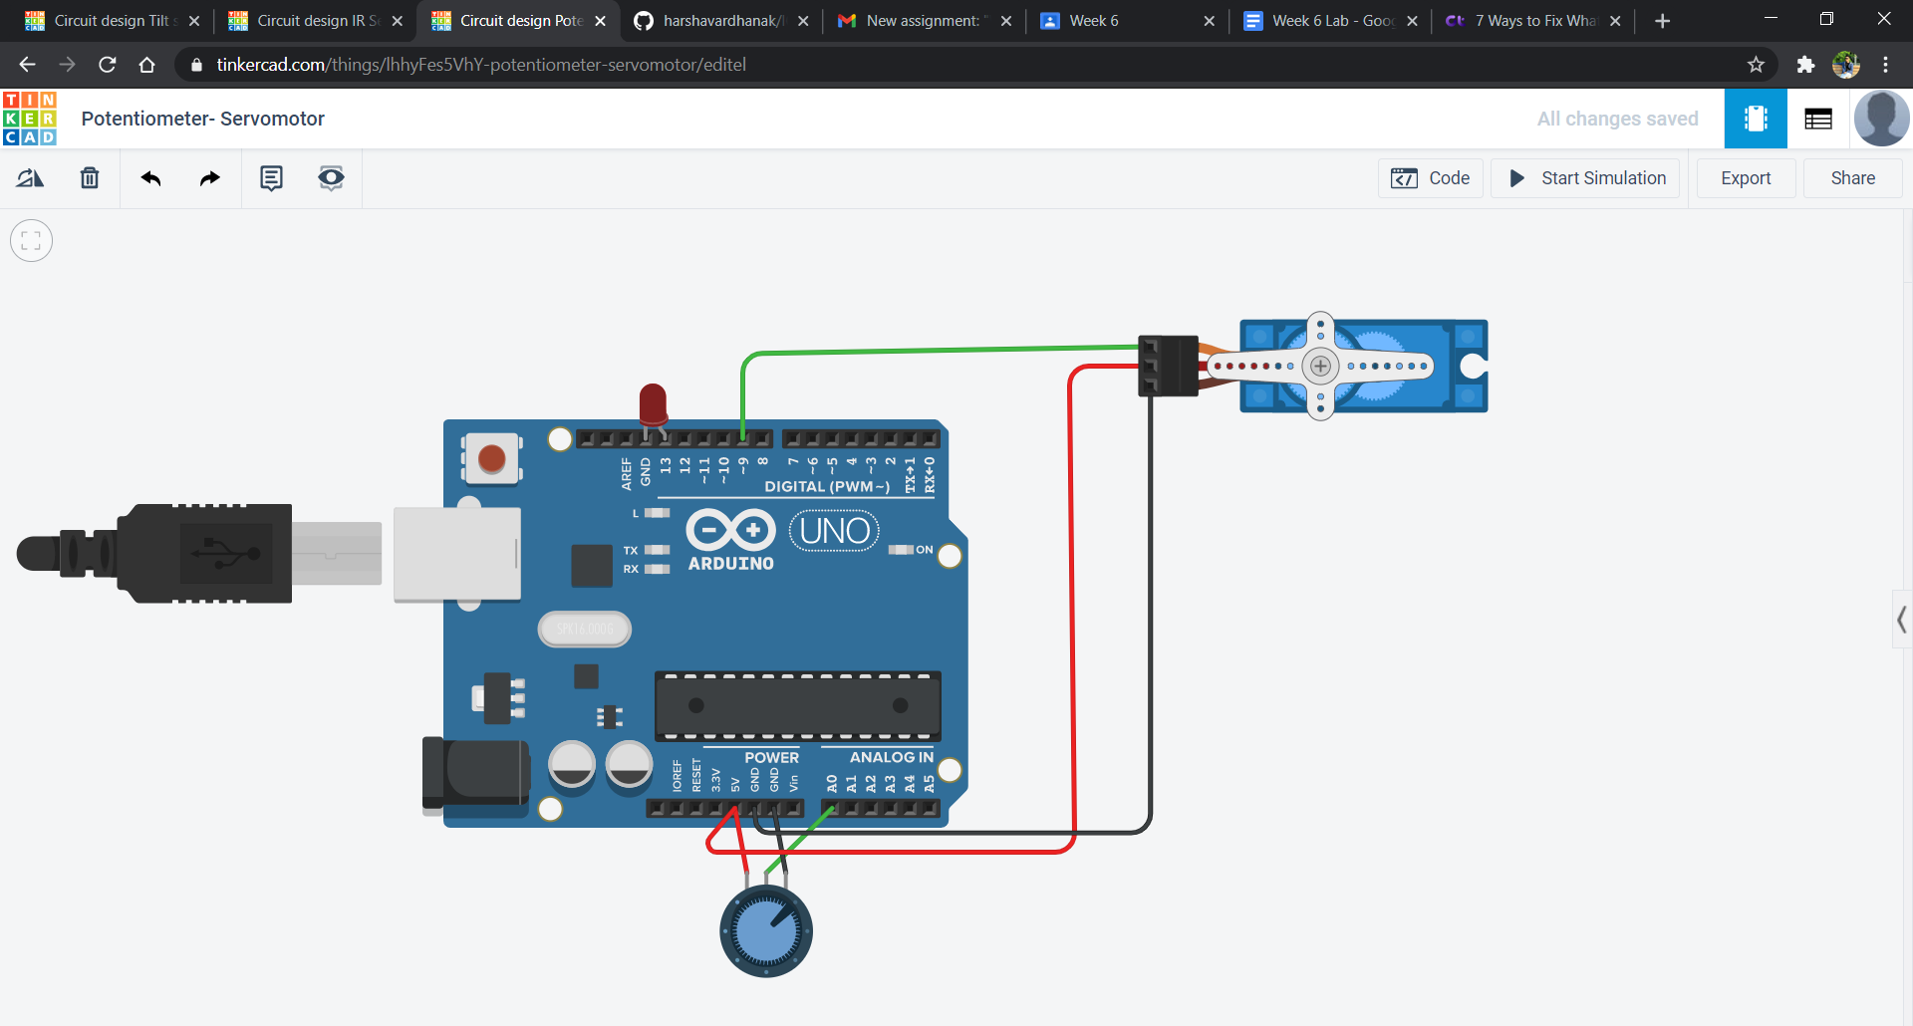

**Circuit diagram along with code:**

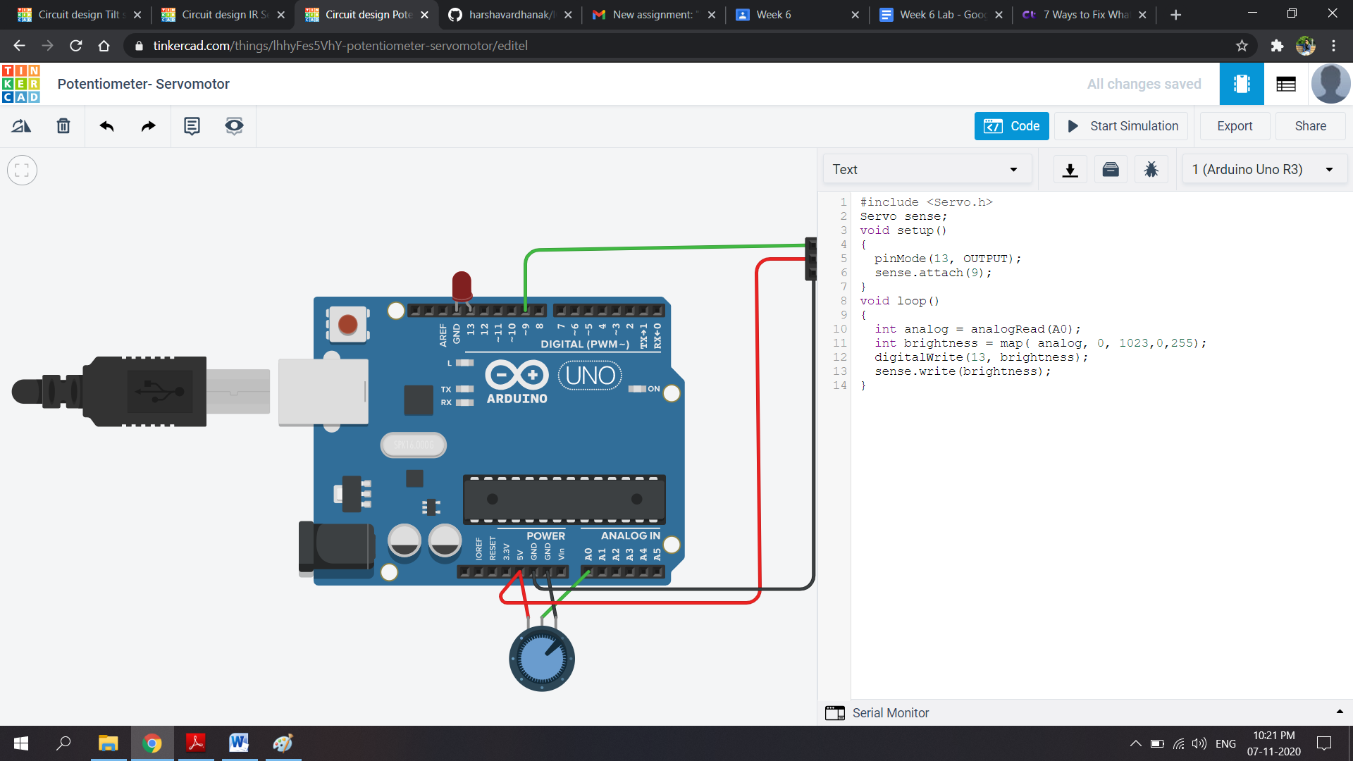

**Simulation:**

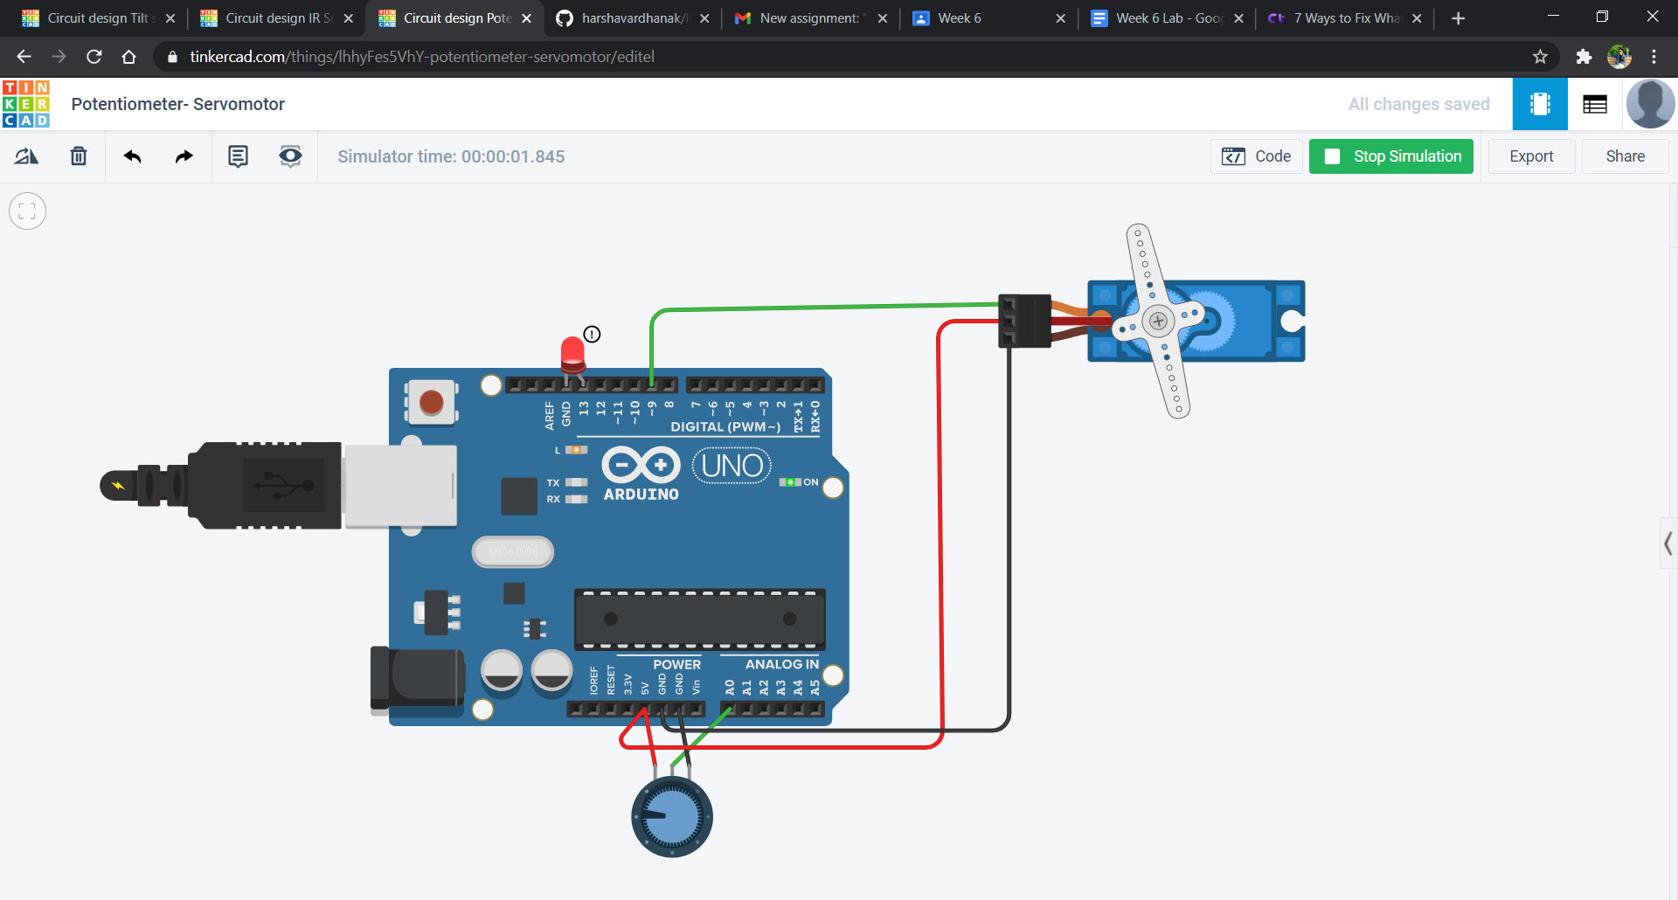

**Code:**

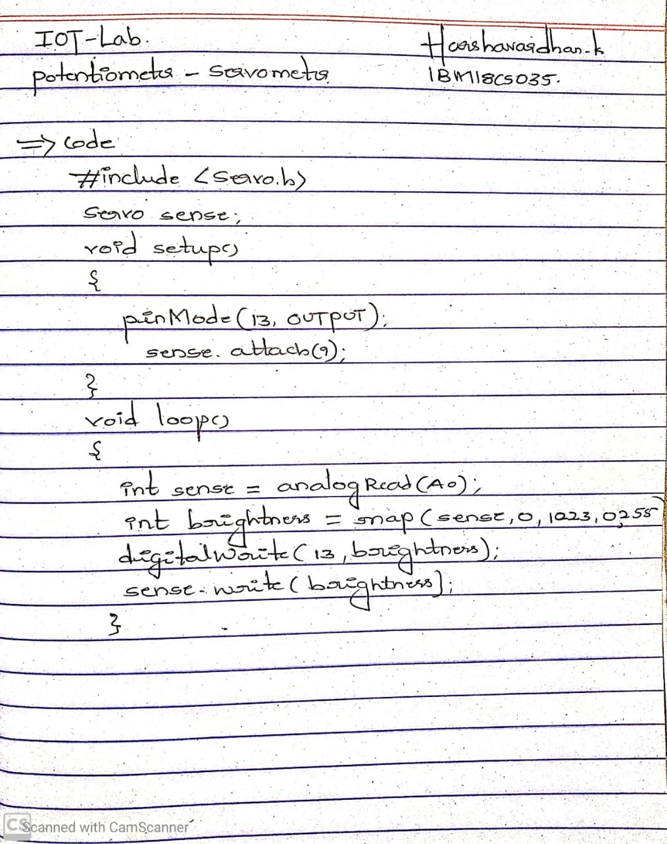

**Observation/output:**

Servo motor shaft rotates.